Sri DNR GOVERNMENT DEGREE COLLEGE FOR WOMEN
PALAKOL, WEST GODAVARI Dist
DEPARTMENT OF POLITICAL SCIENCE

INDIVIDUAL LECTURER PROFILE
BIODATA
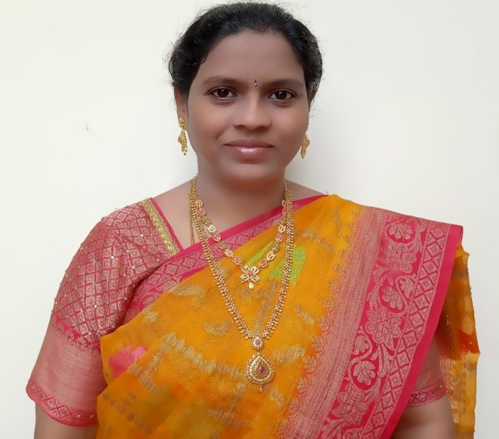

NAME : JYOTHSNA RANI GUNTAKA

FATHERS NAME : VENKATA REDDY

GENDER : FEMALE

DATE OF BIRTH : 12.06.1983

SOCIAL STATUS : OC

NATIONALITY : INDIAN

MOTHER TONGUE : TELUGU

LANGUAGES KNOWN : TELUGU, ENGLISH

ADDRESS FOR COMMUNICATION : H NO 25-4-5,
1ST STREET,
SAMBHUNIPETA
PALAKOL – 53426
WEST GODAVARI DISTRICT.
ANDHRA PRADESH.

CONTACT NO : 8247351576, 9440489038
Email ID : tri.jyo@gmail.com

EDUCATIONAL QUALIFICATIONS:

M.A, B.Ed

TECHNICALQUALIFICATIONS:

- D.C.A, P.G.D.C.A

EXPERIENCE:

- Worked as Guest Lecturer in Civics at Government Junior College, Elamanchili,West Godavari District for two years.

- Worked as Lecturer in Civics at The Lankalakoderu.Sahakara Junior College, Lankalakoderu West Godavari District for Five years.

- Worked as District Co-ordinator for 6 years in West Godavari District under Foundation for Rural and Social Development (an NGO), Secunderabad.

(G.JYOTHSNA RANI)

